Daniel Blaney
Karibu Kenya Report
2/27/11
December of 2010, a group of students from the University of Wyoming travel to Kenya to explore agriculture in a variety of venues. Simultaneously, they travel to experience a completely different culture as honored guests with unique opportunities in the tropics. Travel proved hectic, and the political climate far from relaxed. No major incidences occur however as they travel along late, collecting bugs, and exploring.
Eschel Gardens provides the group its first opportunity to see how integral agriculture is to Kenyan life. Operating primarily as a hotel, the institution also keeps livestock, raises a wide variety of crops outdoors, and operates a greenhouse. Issues with marketing and pest control are discussed with the greenhouse manager, and very strangely developing peppers observed. From there the group is taken to the market, providing many with their first bartering experience. Eschel also serves as home base for the first day of tours, beginning with Vision.
Vision Youth Correction is an agricultural and vocational training program for youthful (17-22) convicts outside of Nairobi maximum security prison. The prisoners, who look more like boys than young men, are shown how to produce a variety of household essentials and non-essentials like soap and imitation juice beverages. The prisoners are also trained in the raising and care of goats and rabbits, in conjunction with small scale crop production integrated with vermiculture. Discussion with the prison administration reveals that the majority of the incarcerated are guilty of violent crime arising from theft. The success rate of the rehabilitation is suggested to be high, and many of the prisoners express hopes of one day operating their own farms.
G-BIACK (Grow-BioIntensive AgriCulture Kenya) is the second facility toured. This institution, a community enrichment organization, serves as an industrial arts and farming school, farm, library, seed-bank, and experiment station. Flyers outlining the threat to local agriculture posed by industrial giants like Monsanto occupy the prominent billboard in the front courtyard, along with how-to guides on a common practice known as double-digging. A mossai garden also sits in the front courtyard, a circular garden surrounding a buried clay pot which will diffuse water into the nearby soil slowly. The rest of the relatively small area of land contains a nursery, rabbit hutch, beds of crops, and experimental site (which possess very little homogeneity between test plots). The heat of the day intensifies, and the trip back to Nairobi begins.
COSDEP is the final facility toured on this day. After providing the group with dinner, a tour of their livestock production operation is offered. Full grown cattle are kept very near the main house in a large pen surrounded on all sides by a massive chicken coop the owner claims holds approximately one thousand chickens. The tour continues to a series of small huts which are being used to produce two common strains of edible mushrooms. Both Agaricus bisporus (button mushrooms) and Pleurotus ostreatus (white oysters) are grown, though this particular program has been operating for a very short time. The conditions in which production occurs leads to the question of; what their rate of contamination is? The manager of the mushroom production does not seem to be terribly interested in at length discussion however.
Flamingo Flower Farms is a stop the next day in the course of traveling across Kenya. This is one of many companies which operate gargantuan greenhouse complexes around Lake Naivasha. Flamingo is distinguished in its environmental awareness having employed a large and expensive water reclamation system alongside a very complex IPM plan. This IPM involves physical barriers, scent traps, small panting trays (for ease of removal and quarantine), and in extreme scenarios application of pesticides. There is however obvious pesticide application occurring during the visit and the claims of water reclamation seem exaggerated given the size of the operation. The roses and variety of other cut flowers produced ultimately reach their primary distributor in London with some likely ultimately traveling as far as the members of the group did for this trip.
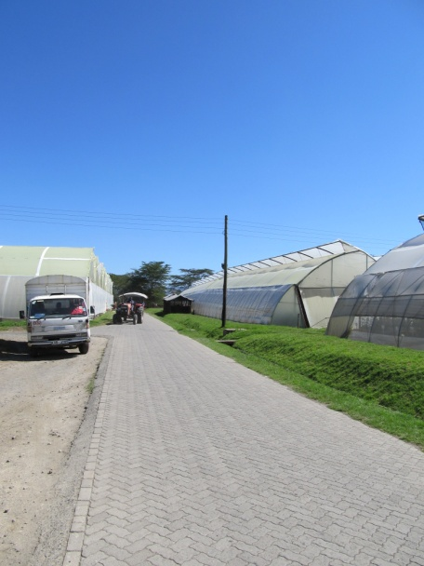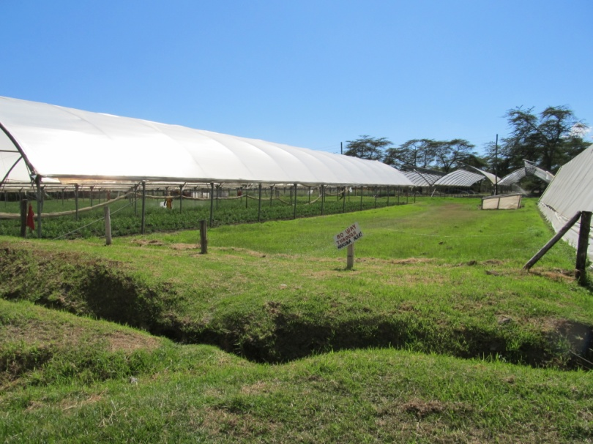
Higher in elevation than the rest of the locations visited, Kericho is the location of the next series of tours. Ketapa tea packaging is the first stop revealing the intricacies of how tea of varying characteristics is blended, bagged, and packaged. International trends in tea consumption are addressed, and a pair of local politicians joins the group. From these politicians it is revealed that Kenya is an invigorated country due to the passage of a new constitution complete with a bill of rights. This same day is the outset of a trail at The Hague involving the former president and the unrest which resulted from his refusal to relinquish the presidency. A visit to fields where large quantities of tea is grown is preceded by a bus ride through miles of identical landscape. Fields of tea interspersed periodically with eucalyptus stands, in untold numbers of square hectares. The fields are heavily fertilized with synthetically produced nitrogen, contain very little biological activity aside from the tea bushes, and closely adjoin natural waterways with only thin barriers of trees guarding the water from receiving leached materials. Many of the fields are harvested by hand with the average worker capable of harvesting one hundred kilograms per day, but increasingly mechanical harvesting is being employed which increases the harvesting rate to approximately 100 kilograms every fifteen minutes. The group finishes with a tour of Kamylot tea processing where the harvested tea is briefly fermented, then dried, ground, and packaged into fifty kilogram bags to be sent to places like Ketapa.
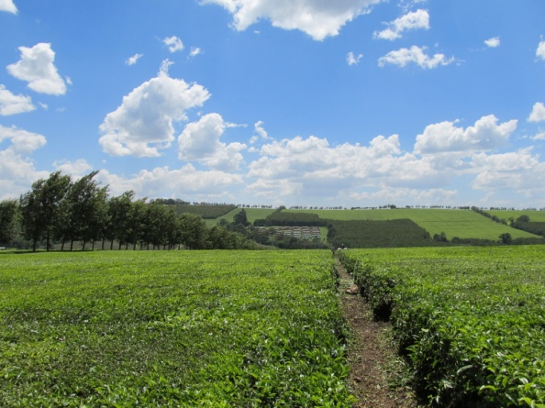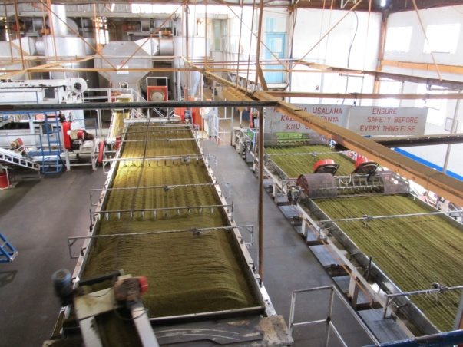
Kitale awaits the group after a drive through an area they are warned is experiencing political demonstration as a result of The Hague trials. The group arrives safely at Manor House, an agricultural education center and mission, and proceeds to celebrate one of its member’s birthdays. The following day they view demonstrations on proper compost pile construction, animal draft power, and participate in double digging a garden bed all at Manor House before proceeding to the farm of a woman named Polly. Polly foregoes a formal exposure to her farm, and instead invites each member of the group to have a soda, observe her animals, and ultimately ride a camel. The following day tours of small community development projects resumes beginning with Macedonia. Here water issues are discussed as well as gender-specific agricultural and social issues. The following two farms are without official names, and one (located deep in a slum where AIDS orphans are a serious issue) is in dire trouble due to the fairly recent deaths of the majority of its founding members. An agro-forestry project is also toured shortly before the group’s departure from Kitale two days after their arrival. Here, models illustrate both the agricultural development of Kenya, along with designs for reducing erosion and maximizing farmer’s land use potential. Wildlife abounds in this area, and a demonstration area exists for harvesting fuel from animal waste. Best of all, fresh macadamia nuts litter the ground around macadamia trees permitting any group member dedicated enough to sample a fresh macadamia nut.
Naturally, the group participates in various leisure activities during their travel as well. Swimming, eating well, shopping, the Nairobi natural history museum and safari are all on the agenda. Breifly, the group’s members are offered the opportunity to interact with one of the few remaining nomadic herding societies left on Earth, the Mossai. The Mossai cattle encroach heavily on the game preserves desired by tourists and conservationists, but they also have few other ranges to graze on. Most likely, this tribe’s lifestyle is not long for this world. With all of this information and experience to assimilate and interpret, the group prepares to travel home through a nightmarish winter storm system over Europe days before Christmas. Some of them return home to extremely concerned families, as a bus is bombed in Nairobi near their departure time. All return safely though, to the credit of a group of exceptional people. Thank you for all your work and tolerance Emmanuel, Dave, Urszula, Nate, Ed, Jeff, Jeff, Polly, and too many more people to list.

